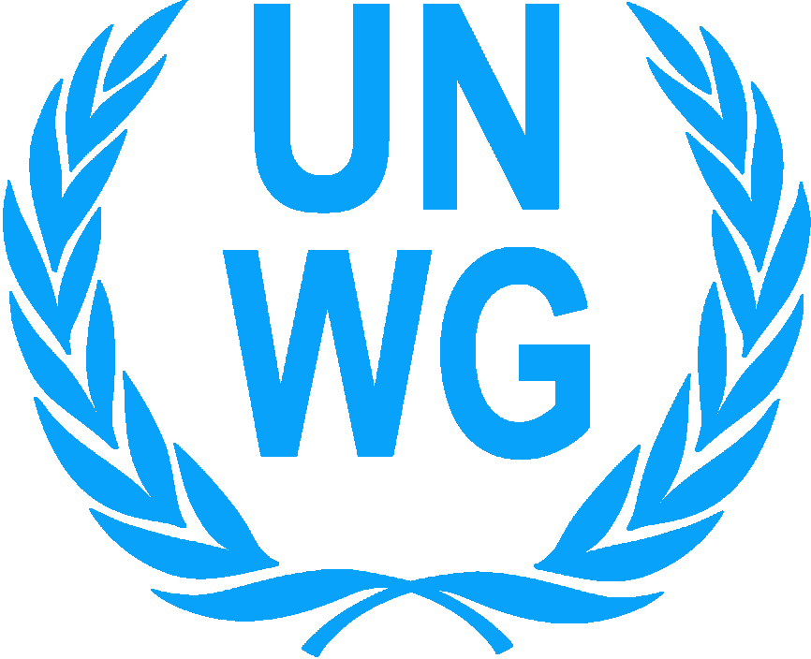 | THE UNITED NATIONS WOMEN’S GUILD OF VIENNA  Vienna International Center, Room F1036, P.O. Box 400, A-1400 Vienna, Austria  Tel.: (+43 1) 2600-24276, 26026-4284, E-mail: unwgcharityvienna@gmail.com,  Homepage: http://unwg.unvienna.org

UNWG APPLICATION FORM FOR CHARITY DONATIONS 2023

PLEASE READ CAREFULLY BEFORE COMPLETING THE APPLICATION
Failure to comply with listed criteria or submission of an incomplete application will result in the automatic rejection of your application
The application is to be submitted between 1st January and 31 March 2023

1. UNWG CRITERIA:
The project must:
- Be for all children without discrimination of gender, race, ethnic origin, or religion.
- Focus on children in need (no older than 18 years or 21 if disabled) or on mother/child programs targeted to the well-being of the children.
- Able to be completed in one year.
- Be sustainable and have continuation plans.
- Address basic needs in health, education, water, and shelter, focusing on long term assistance (e.g., school construction or repair, educational or vocational equipment, classroom furniture, special needs support, medical equipment, clean water supply, sanitation facilities).
- If you have received funds before and have failed to submit a final report, then your application will not be considered for funding.
- Project must adhere to the Declaration of Human Rights, the Declaration of Children’s Rights and the UN Convention on the Rights of Children.

2. UNWG DOES NOT FUND:
- Administrative costs (rents, salaries of any kind, office supplies, telephone costs, travel expenses).
- School fees, school uniforms or writing materials.
- Promotional materials, awareness campaigns or sensitization programs.
- Micro-credit programs or purchase of animals for income generation.
- Revenue generating schemes (e.g.: purchase of computer equipment for a Cybercafé; building construction or purchase of equipment to be utilized/rented out for commercial purposes/ income generating activities).
- Food and emergency aid, i.e., natural disaster, conflict areas, etc.
- Projects benefiting individual children.
- UNWG does not provide retroactive funding, i.e., project activities must be undertaken after receipt of funds.
- Projects without approved building plans and necessary analysis.

Other
- Projects should be implemented directly by the organization applying for the grant.
- Grants can be up to €10,000 or equivalent of this amount.
- Projects may be funded for maximum of three times within a 10-year period.
- The UNWG will fund a portion of a larger project, provided the rest of the funds have already been secured.

3. COMPLETION INSTRUCTIONS
- UNWG prefers applications in the English language, NGO’s may submit in Arabic, Chinese, French, German, Russian or Spanish. However please be aware that we do not have official translators.
- Please type or print clearly throughout the application. We prefer attached Word document files; scans or pictures of your application are difficult to analyze.
- Please do not send .rar files, we are unable to open them. Please do not use Wetransfer or any other time-sensitive transfer service because the files may not be downloaded in the allotted time and will be lost.
- You may add lines or space to describe an item more fully.
- Letters of support from local government entities are encouraged.
- You must provide your organization’s registration certificate as a non-profit organization with the original application form and contact information for the registration authority. If yours is a governmental education or health facility, please provide documentation as to your credentials.
- Please attach any construction plans, any analyses (e.g., hydraulic surveys) and current government approval as necessary.
- Contributions are only transferred in Euros or US Dollars. All amounts should be specified in Euros or US Dollars, except for section 13 where we also request amounts in local currency.
- Only applications on the current 2023 application form will be accepted.

- The original application form must be emailed to:
unwgcharityvienna@gmail.com (no later than 31st March 2023 (midnight Central European Time)
Or sent by post to:
Second Vice President, UNWG
Vienna International Center, Room F 1036
P.O. Box 400, A-1400 Vienna, Austria (postmarked before 31 March 2023)
- For email applications, the signed last page must be scanned and submitted. For postal mail applications, please submit the original signatures.
- Organizations receiving a grant must submit a detailed project completion report, including payment invoices, before 30 June 2024.

4. APPLICATION PROCESS
The UNWG reserves the right to contact organizations to confirm information found in this application. ALL correspondence will be sent to the name and e-mail address that appears on your application form. All applications become the property of the UNWG and will be treated in a confidential manner. We reserve the right to ask for information from other organizations that have a part in the project. The United Nations Women’s Guild of Vienna may use any information, slides, or photographs pertaining to the project for purposes of exhibits, promotions, publications, or any other activity as may be deemed necessary. The list of approved projects will be placed on the UNWG website by 31st July 2023.

Please note: Following the review process, NGO’s will only be contacted if their application is under further consideration.

2023 Application
- PROJECT TITLE:

1a. PROJECT AMOUNT REQUESTED FROM UNWG:
- PROJECT LOCATION, including the country, city, town, village and street address or geographic coordinates of project site:

- LEGAL NAME of applying organization:

4. POSTAL ADDRESS of your organization:

4a. Website URL:

4b. Email Address:

5. HEAD of the organization, email and contact address:
Note: This is the same person who authorizes this application.

Email Address:

6. REFERENCE – If you have a person at the Vienna International Center or in Vienna who can speak about the project, then please provide their name, address, and email. This is not a requirement; therefore, this will not affect your project evaluation process.

A. ABOUT THE ORGANIZATION
1a. Has your organization received funding from the United Nations Women’s Guild Vienna before? |  |  | □ YES □ NO
1b. If yes, when? What was the purpose of the funding?

Please note: If you have received funds before and have failed to submit a final report, including evidence of paid bills, then your application will not be considered for funding.
1c. Have you applied for UNWG funding before, please list in which years and the purpose.
1d. How did you find out about the UNWG Charity Programme?
2. What are the goals and objectives of your organization? (Attach brochures and list web site info)

3. When was your organization founded?

4. Is your organization registered as a Non-profit or charitable organization with your government? A current NGO certificate must be submitted with your application. |  |  | □ YES □ NO
5. Is your organization a government organization? |  |  | □ YES □ NO
6. Please list the projects/activities of your organization during the last 2 years, starting with the latest that you implemented. For each funding source, please include name of contact person, email, and telephone number. Please add additional lines as needed.
Project purpose/activities | Amount | Name of the funding agency |  | Year completed

7. Please provide the following personnel and financial information of your organization:
7a. Number of paid staff working in the organization:
7b. Number of volunteers in the organization:
For each of the following, please indicate Euro (€) or US Dollars:
7c. What was the yearly budget of your organization in the previous fiscal year? (7c=7d+7e+7f) Indicate year.
7d. Amount spent on salaries:
7e. Amount spent on administration:
7f. Amount spent on projects/activities:
8. What is/are your organization’s regular source(s) of funding? We reserve the right to ask for account details if the project is shortlisted. Please indicate Euro (€) or US Dollars
SOURCE |  | AMOUNT | PERCENTAGE
Membership fees |  |  | %
Self-generated (donations/fund-raising) income |  |  | %
Government |  |  | %
International organizations |  |  | %
Others (please specify) |  |  | %
TOTAL |  |  | 100%

B. PROPOSED PROJECT FOR UNWG FUNDING:
(Please attach relevant brochures, documents and 4 photographs)

1. Briefly and clearly describe the project you are applying for UNWG funding.
2. What will be the impact of this project in your community? State the problem this project will address and explain how this will be sustained and/or continued in the future. Use attachment if necessary.
3. Number of children the project will support:
In case of a mother-child project, please specify the number of:
Boys: Girls: Women:

4. Ages of children:
5. Please give details of disability and/or special needs among children that this project will serve:

6. When do you expect the project to start?

7. How long will it take to complete the project?

8. In chronological order, describe the steps of the plan and implementation dates of each step (note the funds will not be transferred before June 2023). Project must be completed within one year of the receipt of funds.
PLAN STEP |  | EXPECTED DATE
9. What is the estimated TOTAL cost of this project?
10. Amount requested from UNWG
11. Are other organizations/donors contributing to costs? |  | □ YES □ NO
11a. Funding detail when other donors are supporting the project:
Source and Contact Information | Amount in € or US$ | Which part of the Project is to be supported?
12. Are you also applying to other organizations/donors for this project? □ YES □ NO
12a. Please provide more information on your application to other donors:
Source and Contact Information | Amount in € or US$ | Which part of the Project is to be supported?
13. ITEMS to be funded by UNWG:
Please list items to be funded using the UNWG funds and the approximate cost of each item.
Where possible, please enclose documents supporting the costs and/or cost estimates from suppliers.
ITEM |  | COST (in Euro or US dollars) | Cost in local currency
Example: 3 children’s desks @ €50.00 each |  | €150.00
Total Cost of Items
Total cost to be paid for by UNWG

C. BANKING INFORMATION

1. Please specify HOW you would prefer payment, if your project is approved for funding:
□ US $ □ €

2. Please complete the following information on the bank where the funds will be deposited:

Name on account
Account number
Bank name
Bank address
IBAN (International Banking Number)
SWIFT Code
Authorization Code to receive foreign funds (where appropriate)
The Name on the Bank account should be the name of the organization applying for funds.
Before signing this application, check that you attach all required documents
- Attached a current, up to date and valid NGO certificate
- Attached quotes for the items you wish to purchase with a UNWG grant
- Attached building plans, and analyses as needed
- Read through the criteria and list of items that the UNWG does not fund, and confirm that your project meets our criteria

Incomplete applications and applications that fall outside of UNWG criteria and guidelines will be rejected automatically.

D. Submission

This application has been authorized and submitted by:

Name of the official: (same as on page 3 item 5 of this application)
Title of the same official in the Organization:
Signature of the same official:
Date:
Stamp/Seal of the Organization:
Please sign and submit this page with the application.
A scanned copy is acceptable for electronic submission.

